# CNC – Project Description

The operating principle behind this machine is that it cuts solids of revolution out of a block of Styrofoam. The machine is based on a cylindrical coordinate system with the three axes being Z, R, and θ. These axes are computer controlled and so can be automated to create a variety of intricate shapes.

### Front View

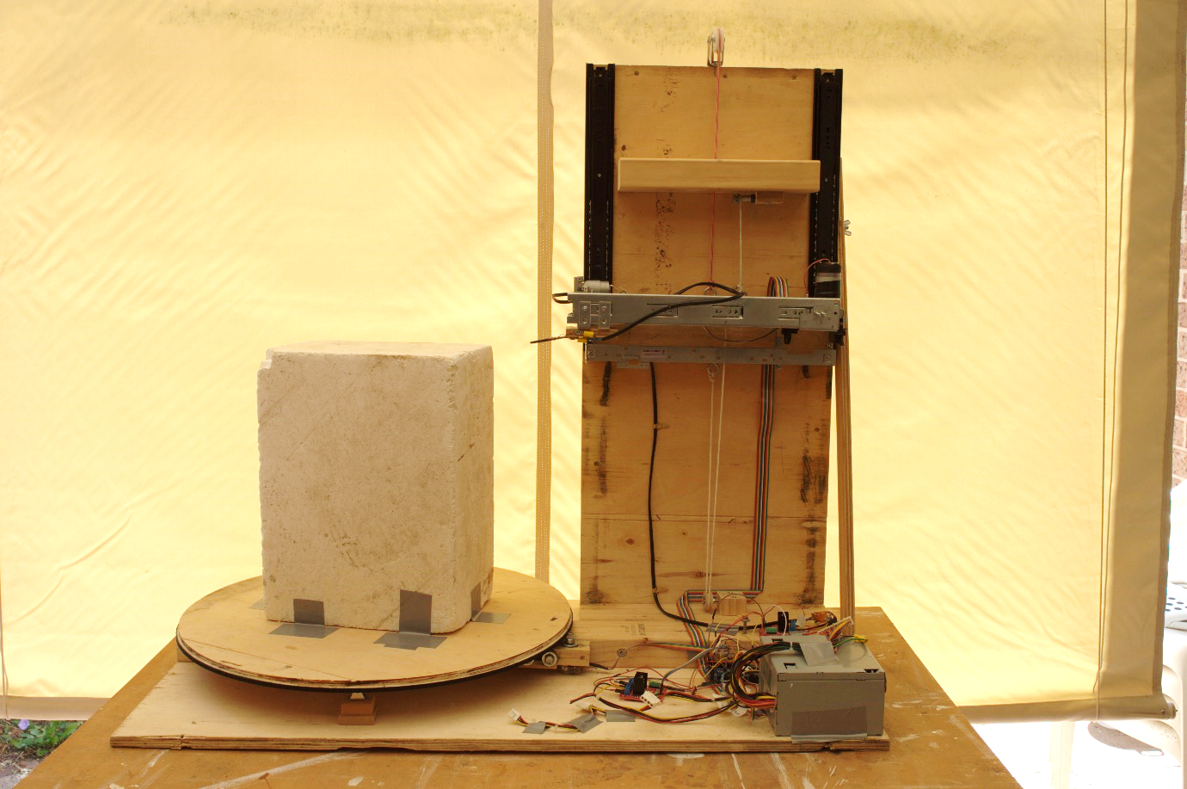This image depicts a front view of the CNC machine. The left of machine holds the turntable. This is a motorised platform (θ axis) on which the workpiece sits. The control electronics, consisting of an Arduino microcontroller, sensors, and motor driver circuity are housed in the base of the machine, and can be seen in the bottom of the image. The vertical board which extends from the machine is the support for the cutting element arm. This arm can ride up and down along the board (Z axis) and also extend a portion of it with the cutting element perpendicularly forward in the R direction.

### Cutting Element

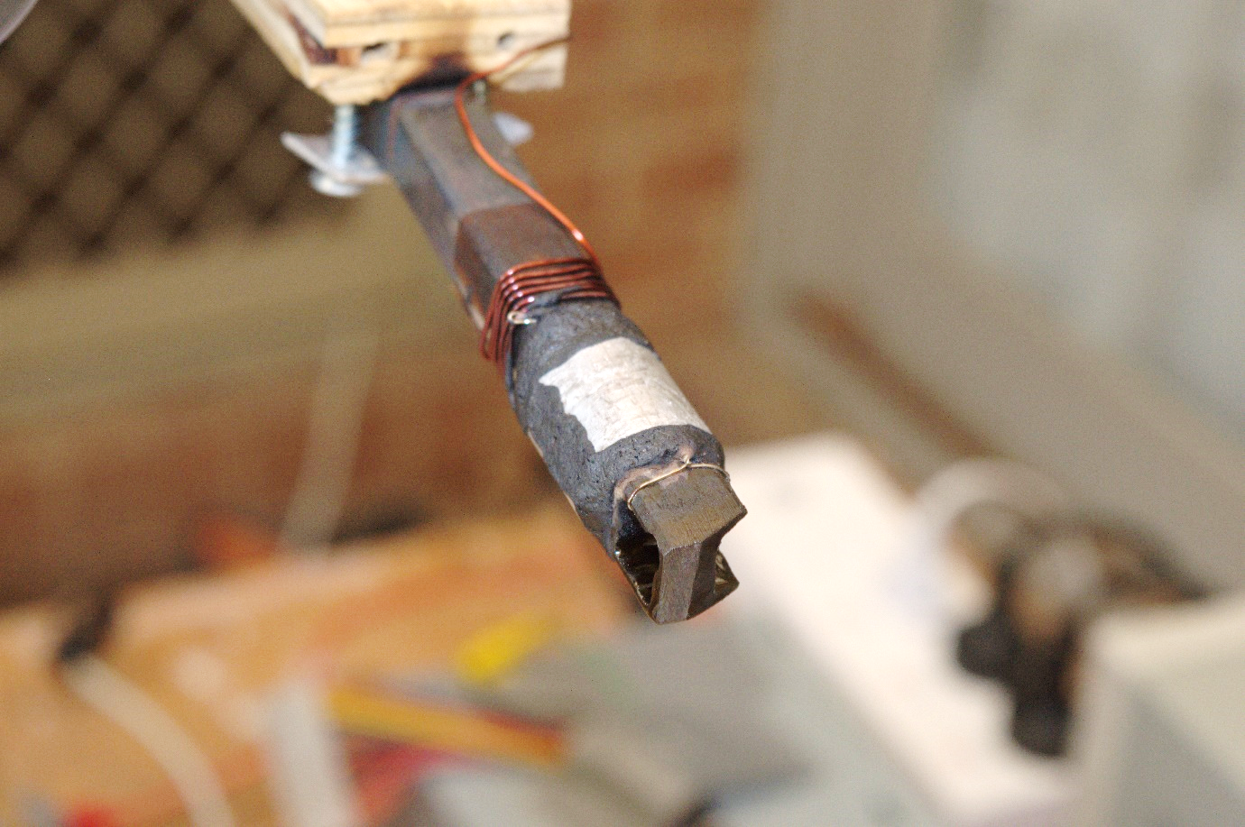

The cutting element went through many iterations throughout the design process. The final design consisted of an electrically heated steel element. The tool is optimised to cut through Styrofoam and has adaptations for this. The element is electrically heated, which allows it to easily melt through the Styrofoam. The bevelled tip creates a sharp point of contact, and thus high pressure on the Styrofoam to be cut, lessening the force required. The large hole in the centre of the cutting region allows a large portion of the Styrofoam to pass through the tool without being melted or cut. This greatly reduces the work required to cut the Styrofoam as only the edges need to be removed, instead of the whole area.

### Device in Operation

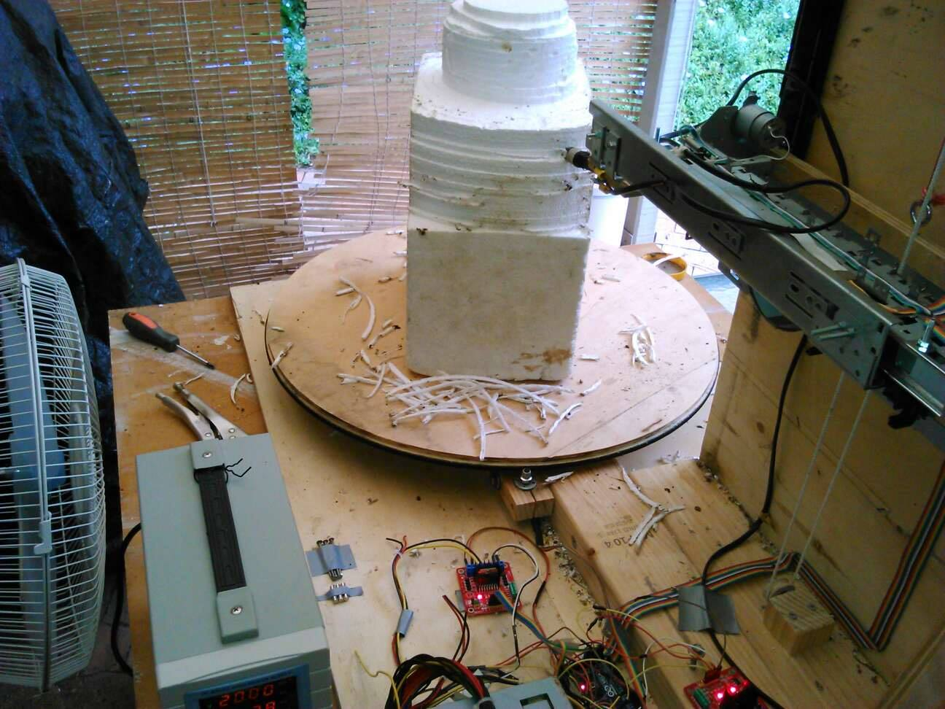

This in-action photograph of the CNC captures many of its design characteristics. The subtractive nature of this manufacturing method can be seen in multiple passes that the cutting element is taking to gradually carve the shape out of the block. The R and Z axis can also be seen partly extended. Programming these axis to move into a precise location involved a bit of work. The low cost dc motors used have no inherent positional knowledge and so they were combined a positional encoder determine their position at any time. Due to inherent non uniformities in the axis, a constant voltage delivered to the motor would not necessarily deliver a constant speed, causing uneven motion. To fix this the positional information was fed into a PID controller which adjust the voltage depending on the distance from the target location, cumulative error, and current speed, effectively eliminating the problem.

### D:\data\Downloads\Inkjet CNC\Referential Media\48403305_334474677374913_4565536517522456576_n.jpgMachine Output

The above is a shape, cut out with the machine. The step size was set rather course on this piece, hence the noticeable ridging. Overall the finished surface quality is high, with minimal beading and accumulated Styrofoam from the cutting operations. It is noticeable that there are some indents on the piece. This was caused by the platform getting temporarily stuck in one location. When this occurred the ambient heat from the cutting element caused the nearby Styrofoam to melt and shrink slightly. This shape was specifically chosen to test undercuts and concave elements, specifically, if the software developed to generate the machine instructions would recognise that the heating element arm would collide with the piece for too great an undercut, this it successfully avoided.